**CP1406 - Assignment 1 - Project Plan - CossiePlay**

**Name:** Kane Avery Sia Si Kai  
**Login:** JC441652 (13369779)

**Mission Statement:**

To Enable CossiePlay to increase and awareness and improve their business interactions with existing and potential customers through the use of an established online platform.

**Success Evaluation**

Clients at Cossieplay are hoping to improve their business and raise awareness about their store. Over a time period of 3 months, the number of new customers with be compared over the previous 3 months to see if the number has increased. If the number has increased the website would have fulfilled its purpose by increasing awareness (New customers visiting the store) and improve business (New Customers making purchases).

**Target Audience**

* Existing Customers whom have frequent CossiePlay. (Ages 35-50)
* By posting new events on the events and activities page so existing customers can find about these new events by visiting the website.
* Potential Customers who might be interested in cosplaying. (Ages 15-30)
* By informing them about what is CosPlay and the various event and services provided by Cossieplay to spark their interest in Cosplay.

## Site Flowchart (Structure Diagram)

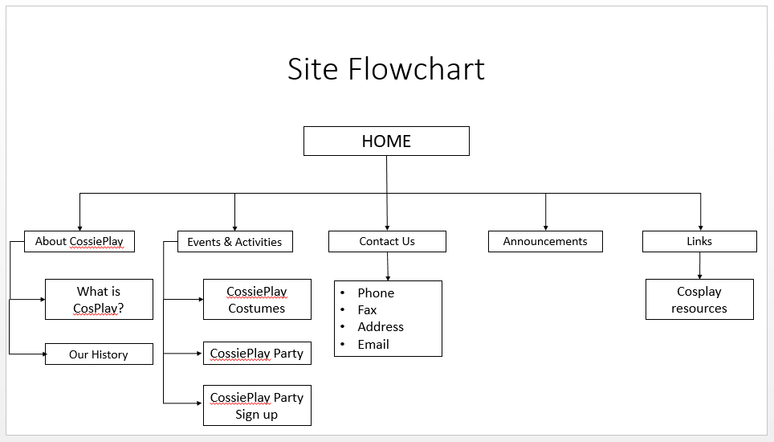

## GitHub Repository

## CP1406 - Web Design and Development assignment 1

## https://github.com/KaneAvery/assignment1.git